 | Customer Insights · Sprint Review
New insights — Editor
Quantitative summary for PMs · Lime Survey questionnaire · n = 119 respondents · 23 Jul 2026

236  Survey responses | 119  With feedback | 30  Insights extracted | 19  Taken forward | 13  Merged into existing | 6  New records (485, 487–491) | 11  Rejected
Database now 377 records · 7 created in this study, #486 consolidated → ID 140 (14) 4 bugs logged to bug list (8 → 12) 11 rejected = 10 bugs + 1 feature (DMS drag-in) #15 also spawned new record #488 (save own prompts)
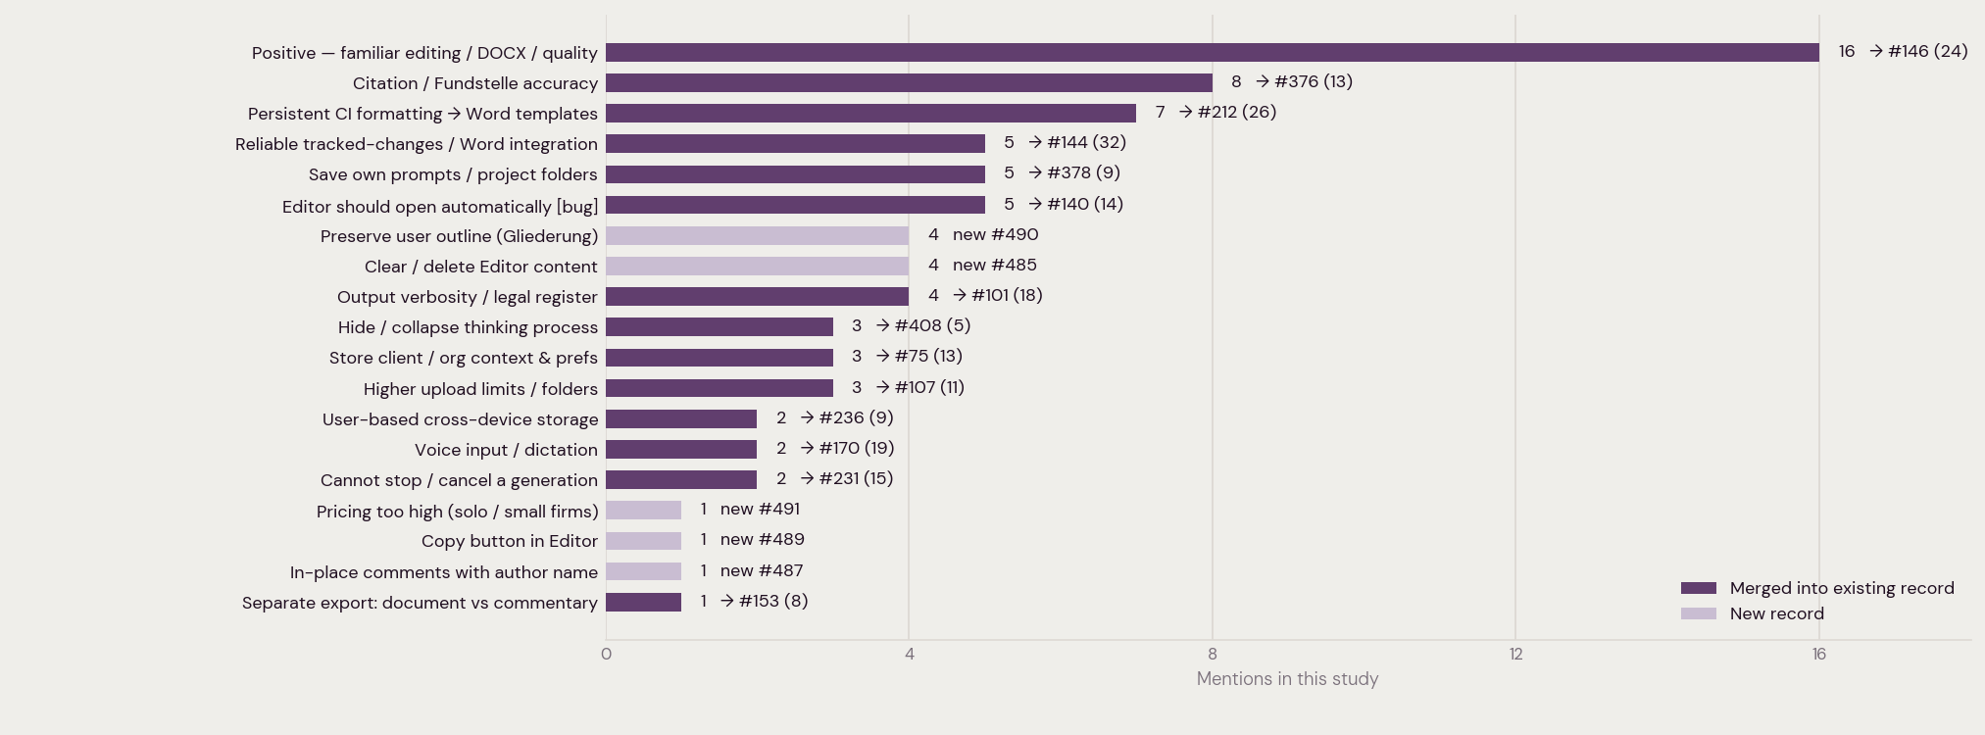
19 insights taken forward, ranked by mentions in this study. Bars show whether each fed an existing database record (with its new running total) or created a new record.

